Don’t Let the Computer

Eat Your Vote…
…Demand hand-counted paper ballots in 2004.

*Join us at noon, July 13, 2004, for the National Day of Action on Verifiable Voting.

Call 303-231-1031 for location and details.
WHO WE ARE: Coloradoans for Voting Integrity (CFVI), a non-partisan, not-for-profit group of Colorado citizens working to ensure fair and verifiable elections.
WHAT WE WANT:
- Hand-counted PAPER BALLOTS for 2004.
- Paper ballots that can be recounted. Right now, Colorado Revised Law requires that any vote by machine is also recounted by machine, which can only produce the SAME result.
WHY SHOULD YOU CARE?
- Computerized elections are subject to software crashes, hardware failures and power outages.
- All elections are subject to fraud. Computerized elections are subject to grand scale fraud.
- This may be the most important election of your lifetime. Shouldn’t you be certain your vote is counted?
*If you can’t make it July 13, visit www.cfvi.org to learn about other ways you can help ensure fair elections.

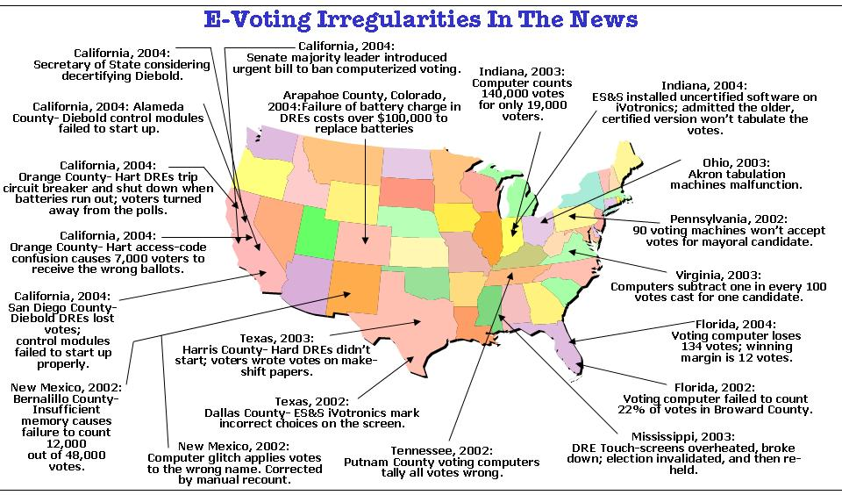

www.CFVI.org
Telephone: 303-231-1031
Fax: 303-235-0124
Time Is Short— ACT NOW!

